**A graphical user interface**

**on European time use**

**Final report**

**Camille COCHENER**

**Hélène DANLOS**

**Romain LEGRAND**

**Sophie LEVEUGLE**

**Rodolphe SIMONEAU**

**1. The dataset**



For this project, we decided to work on the **Time Use Dataset**, an exciting and entertaining dataset about how people spend their time depending on country, sex, and different types of activities. It is one of the “less common datasets” proposed for the project. The source is Eurostats, and the data is obtained from the HETUS study.

The dataset is primarily contained in a csv file called **TimeUse.csv**. However, because we felt this dataset alone could not answer all the questions we wanted to address, we complemented it with a second file called **tus_00startime.csv**. This dataset is also provided by Eurostats. It is provided as an extension to the base TimeUse dataset and treats the same topics, but from a more timely perspective.

**1.1 The TimeUse dataset**



At a glance, the TimeUse.csv file looks as follows:

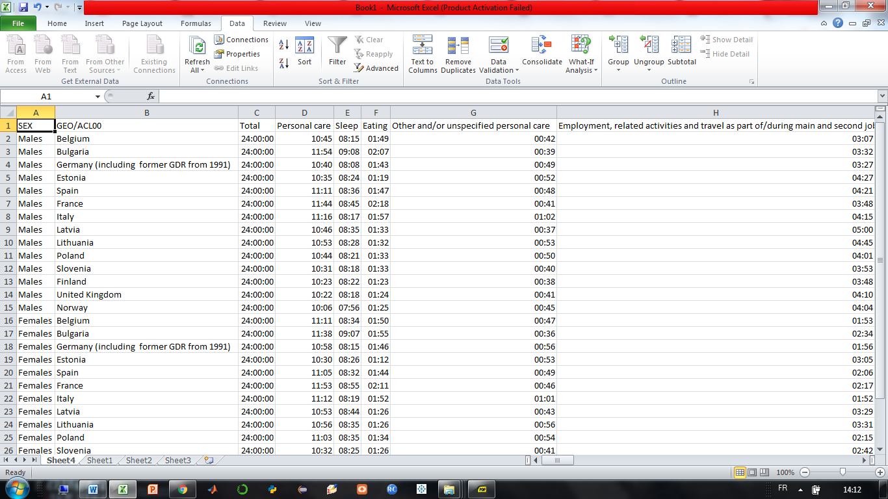

Figure 1. the TimeUse.csv file

The dataset is organized as a table comprising 28 rows and 58 columns, for a total of 28 cases or observations (one per row). It contains three main attributes: gender, country, and activities. Let’s look at this into more details.

Gender or **Sex** is the first column of the dataset. It is a qualitative variable which can take two different values: Males, or Females.

**Country** represents the second column of the dataset. It is again a qualitative variable. The dataset considers 14 European countries: Belgium, Bulgaria, Germany, Estonia, Spain, France, Italy, Latvia, Lithuania, Poland, Slovenia, Finland, United Kingdom, and Norway.

**Activities** represent the remaining 56 columns of the dataset. All the activities are quantitative features which represent the average daily time (in minutes) dedicated to a given task. The first variable “Total” sums all activity times to 24 hours, as one might expect. A key feature of the dataset is that activities are organized in a hierarchical way: there are general categories of activities, then subcategories within each general category. In this sense, the dataset is redundant as it provides durations for both main categories and subcategories. Considering the whole dataset, there is a total of 5 general categories, and 50 associated subcategories. They are distributed as follows:

* Personal care: includes sleep, eating, and other personal care activities.
* Employment: includes main employment, and employment-related activities.
* Study: includes schooling, homework, and free time study.
* Household and family care: includes food management, dishwashing, cleaning, household upkeep, laundry, ironing, producing textiles, gardening, tending domestic animals, pet care, walking the dog, construction and repair, shopping, childcare, teaching, and household management.
* Leisure and social life: includes organizational work, help to other households, participatory activities, visiting and feasts, other social life, entertainment and culture, resting, walking and hiking, sport, computer games, computing, games, reading books, other readings, TV and video, radio and music, and other leisure.

**1.2 The Startime dataset**

The TimeUse dataset is rich in information about time use in European countries, but it fails at telling the story of *when* people are busy on a given activity. For this reason, we decided to supplement the initial TimeUse.csv file with the file the tus_00startime.csv which specifically explores this aspect of the subject. A preliminary view of the tus_00startime.csv file is given by Figure 2.

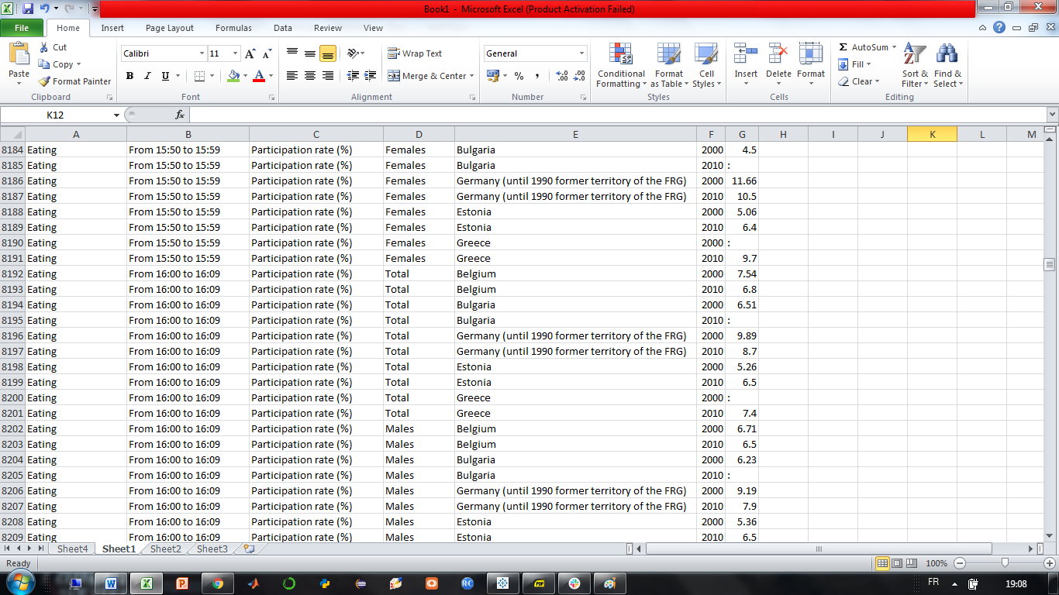

Figure 2. the tus_00startime.csv file

Unlike the TimeUse dataset which focuses on time durations, the Startime dataset concentrates on **time schedules**. Precisely, it provides participation rates for different activities at different time periods of the day. It is organized as a table containing 27001 rows and 7 columns, for a total of 27000 cases (one per row). The columns consist of 7 attributes: activity, time period, unit, gender, country, time, and value. Let's dig deeper into this.

**Activity** is a qualitative feature. It represents the activity being considered. It is important to understand that the activities in this dataset do not correspond exactly to the activities in the TimeUse dataset, because the two datasets aggregate the sub-activities differently. This dataset comprises eight categories in total: eating; household, family care and related travel; leisure and social life excluding TV and video; personal care except eating; travel to/from work/study; TV and video; work and study; and unspecified time use and travel.

Startime or **time period** indicates the period of the day at which the activity is conducted. It consists of 10-minute slices provided as a pair of start time, end time (for instance: “from 18:50 to 18h59”). Even though it represents numbers, it is not quite a quantitative variable. Rather, it represents a qualitative variable of ordinal nature (in the sense that we may order the different time periods). All the time periods within a day are considered, so that the set starts with the 00:00 to 00:09 period and ends with the 23:50 to 23:59 period.

**Unit** is boring. It is merely a label indicating that each observation is expressed as a participation rate. As such, it does not provide any additional information and could in fact be omitted.

**Sex** represents the gender. It is a qualitative, nominal variable that contains three categories: Males, Females, and Total.

**Country** represents the country of interest. It is similar to the country variable in the TimeUse dataset, and thus contains the same 14 values: Belgium, Bulgaria, Germany, Estonia, Spain, France, Italy, Latvia, Lithuania, Poland, Slovenia, Finland, United Kingdom, and Norway.

**Time** is a qualitative variable representing the year at which the survey was conducted to obtain the data. Its value is either 2000 or 2010. It is merely a metadata and is thus of limited use.

**Value**, finally, constitutes the most important variable in the dataset. It gives the participation rate for the selected activity, at a given time, for a given country, in percent.. It is quantitative and represented by a float between 0 and 100.

## 1.3 Combining both datasets

In order to combine properly the two datasets, we made a join on the country, using only the 14 countries present in the first dataset.

As discussed in the previous section, the structure of activities is not similar between both datasets. Compared to the first one, the second dataset:

* combines work and study together
* considers eating separate from the other personal care activities
* considers TV/video separate from the other leisure activities.

In order to have a consistent representation, we need to choose one convention. Although there are pros and cons for each representation, being able to see “eating” at a high level is more important for a traveler than the split between work and study, thus the choice for the structure of the second dataset (the choice might have been different if our users had been people interested in sociology).

This results in the following allocations of sub-activities from the dataset 1 to each aggregated category of activities from dataset 2 (according to the metadata information available in Harmonised European Time Use Surveys (HETUS) ) :

* Eating
* Personal care except eating: includes sleep, personal care and other and/or unspecified personal care activities.
* Work and study: includes main and second job, employment-related activities and related travel, schooling, homework, and free time study.
* Household, family care and related travel: includes food management, dishwashing, cleaning, household upkeep, laundry, ironing, producing textiles, gardening, tending domestic animals, pet care, walking the dog, construction and repair, shopping, childcare, teaching, help to other household members and household management.
* Leisure, social life and associate life except TV and video: includes organizational work, participatory activities, visiting and feasts, other social life, entertainment and culture, resting, outdoor activities, walking and hiking, sport, computer games, computing, games, reading books, other readings, radio and music, and other leisure.
* TV and video
* Travel to/from work/study
* Unspecified time use and travel

**2. The target users**

We live in a globalized world and that’s for the best. People move from one country to another and discover new people, cultures, and ways of life. However, while exciting, moving to another country might also prove an intimidating experience. People about to move abroad might wonder whether it will be easy for them to find friends sharing their favorite centers of interest and hobbies. Or maybe they just wonder if the local time schedule won’t be at odd with their own habits. Possibly also, women may wonder whether gender equality applies better abroad than at home.

In this project, our central concern is to assist **people who are about to move abroad**. It can be tourists who go on a short-term visit of exploration in a foreign country, but also people about to move abroad in the longer run, for instance for professional or family reasons. Our initial assumption is that a user of our application may have **little to no knowledge of the underlying datasets**, and also **limited experience with data visualization tools**. The application must thus be simple, easy to understand and to grasp at a glance. This motivated the choice of **Tableau** for our visualization software. Tableau provides very rich and informative representations, while still delivering clear and intuitive messages thanks to its system of stories and dashboards. It is also very accessible for inexperienced users.

Given this user profile and the dataset, we thought someone considering our application might be willing to answer questions along three fundamental axes: discovery/comparison, time duration/time schedule, and male/female.

**2.1 discovery vs comparison**



Typically, someone moving abroad may be interested in two aspects of life abroad: **discovering** how time is spent among the different activities in the destination country, or **comparing** how time is spent between the origin and destination countries.

Examples of discovery questions are:

* How much time do people spend eating in European countries?
* How much time per day does a British citizen spend visiting and feast?
* How many minutes does an Italian dedicate daily to ironing?
* How many hours do you spend at school every day in Bulgaria?

On the other hand, examples of comparison are:

* Are there some other European countries with similar eating habits as Belgium?
* What are the main differences in how French and Estonian spend their time?
* As a Finnish, should I prepare to adapt my schedule if I move to Spain ?

**2.2 time duration vs time schedule**



The second axis consists in a time duration vs time schedule perspective. Consider for example a French compatriot moving abroad. As is well-known, eating is an essential activity for any self-respecting French citizen. Our traveller may thus be willing to make sure that in the destination country, enough time will be dedicated to eating on a daily basis. This is the **time duration** aspect of the question. While quite informative, it does not tell the full story. Indeed, our traveller may also wish to make sure that meal times won’t be too different from his local habits. For instance, it may be somewhat tough to get used to having dinner at 6.30 pm in Germany, while French typically eat around 8.30 pm. This is the **time schedule** aspect of the question.

Examples of time duration questions are:

* How much time a day do Spanish people dedicate to sport?
* How many minutes a day do people in Lithuania dedicate to gardening?

Examples of time schedule questions include:

* At what time do the Finnish typically have breakfast?
* At what time should I go to the restaurant in Italy??

**2.3 male vs female**



The final axis consists in a **gender** comparison. Unfortunately, we know that men and women don’t stand yet on an equal footing regarding certain tasks such as domestic chores and childcare. Also, not all countries have invested the same effort towards gender equality. Someone moving abroad may thus be willing to know whether women condition and gender equality is better or worse in the destination country.

Examples of gender questions include:

* Are chores equally distributed between men and women in France?
* What leisure activities are gender specific in Germany?
* Are women heavier readers of books than men in Italy?

**3. Chosen design**



**3.1 questions that guided the visualization design**



With our datasets and visualization axes at hand, the next step consisted in building the visualization design. This is no trivial tasks, and a number of questions helped us to decide on how we would organize our application. The first question was related to **intuitiveness**: how can we make sure that a user with limited experience would not feel lost when handling our visualization device for the first time? How can we guide the user to navigate step by step during the navigation? To answer this question, we decided to organize our visualization in a way that would take the user by the hand and render navigation perfectly natural.

Consider for instance Figure 3, which represents the welcome page of our application (more about the design itself later!). The page is organized in a top-to-bottom and left-to-the-right fashion, which corresponds to the natural processing of human vision. At the top of the page within a blue banner lies the title (blue frame). Then, getting down one step, the user must first select a country, then an activity (orange frame). The numbers help making sure the parameters are selected in the right order. Then comes a grey banner that visually separates the parameters from the visualization itself (green frame).

Finally, on the right of the visualization comes a description of the available interactions, each of them being flagged by an arrow (purple frame). Placing these elements on the right is a purposeful choice which ensures that the available interactions are placed at the spot where the vision process ends. This way, the user’s look is naturally attracted by the different visualization features available. A similar organization applies to the other elements of our application, in the hope of always providing the simplest possible navigation experience.

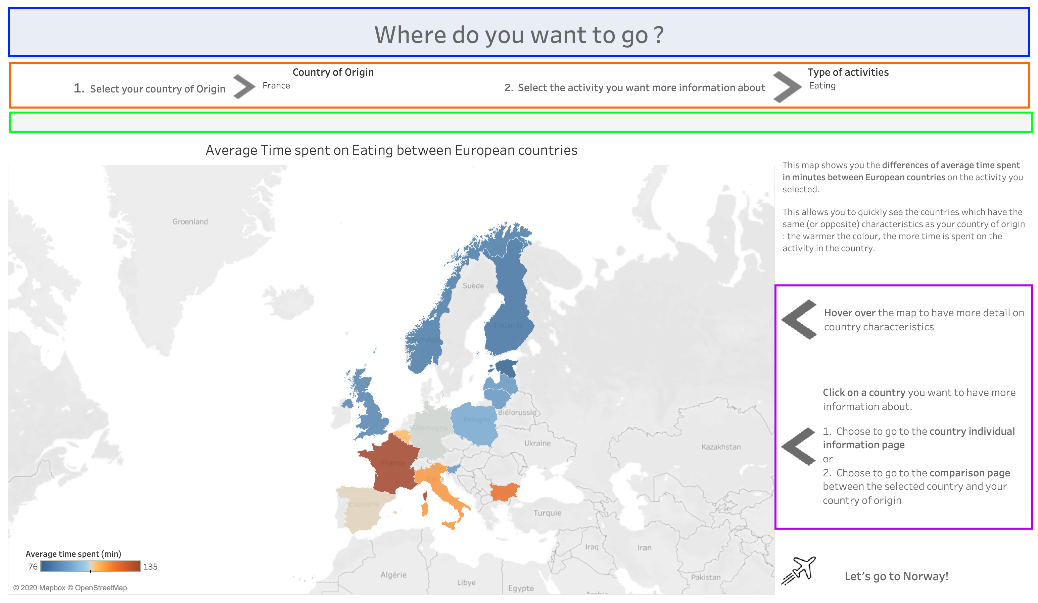

Figure 3. the Welcome page of the application

The second question that contributed to build our design was that of **comfort.** Looking at Figure 3, it should be clear that a single element of our visualization device may already fill almost a full page. For this reason, we felt it was necessary to distribute our representations across several tabs, in order to avoid excessively small graphics and preserve a satisfactory visualization experience.

Fortunately, Tableau offers great functionalities in this respect. **Dashboards** permit to combine several different visualizations or “sheets” in a single page, and **stories** permit to assemble different dashboards as separate yet interactive tabs. Consider for instance Figure 4. It shows one of the dashboards of our application that combines several visualization sheets. Every graph is sufficiently large to provide a good visualization experience. Also, the dashboard is part of a story, hence the buttons at the top (blue frame) to navigate to other adjacent dashboards.

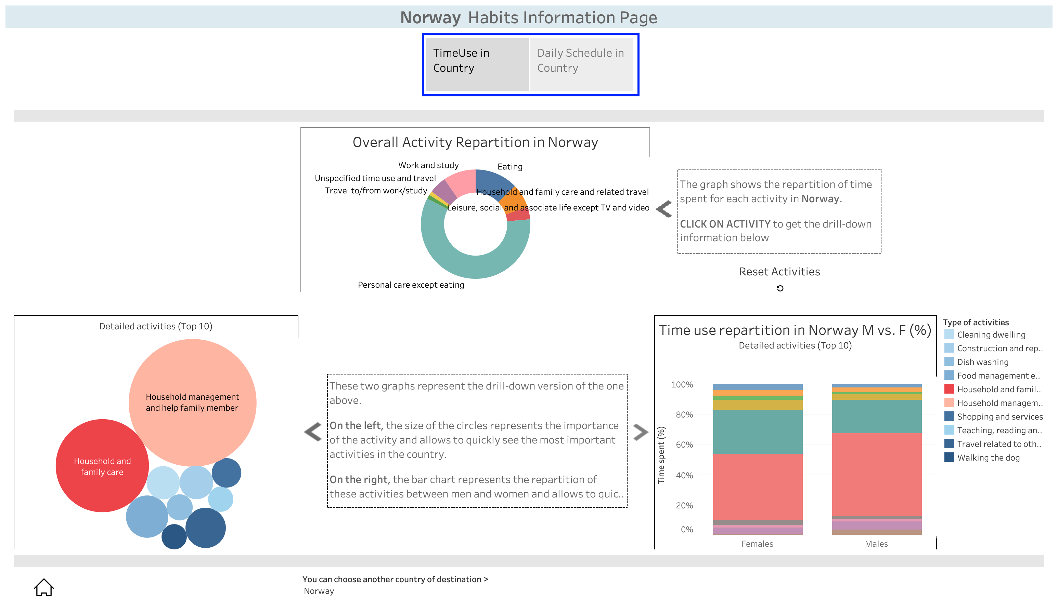

Figure 4. a dashboard in our application

The final question that contributed to build our design was that of **clarity**. As previously mentioned, our visualization aims at answering questions along three different axes. In this respect, it is essential that the axes can be properly separated in the visualization design in order to avoid confusion. Here again, the organization of Tableau into stories comes handy. Figure 4 for instance displays a dash on the duration side of the time duration/time schedule axis. Yet clicking on the right button at the top instantaneously transports the user to the time schedule dashboard corresponding to the same country. This way, the different axes are clearly separated, yet easy to navigate one from another.

Now that the building motivations have been developed, it is time to formally introduce our chosen design.

**3.2 Representations and interactions: welcome page**



The welcome page of our project is displayed in Figure 5. It is simply a **map of Europe**. Clearly, **a map sounds like the most natural representation for someone about to travel**. In addition, everyone is familiar with the map of Europe, so that the visualization will make sense even for users unfamiliar with visualization in general.

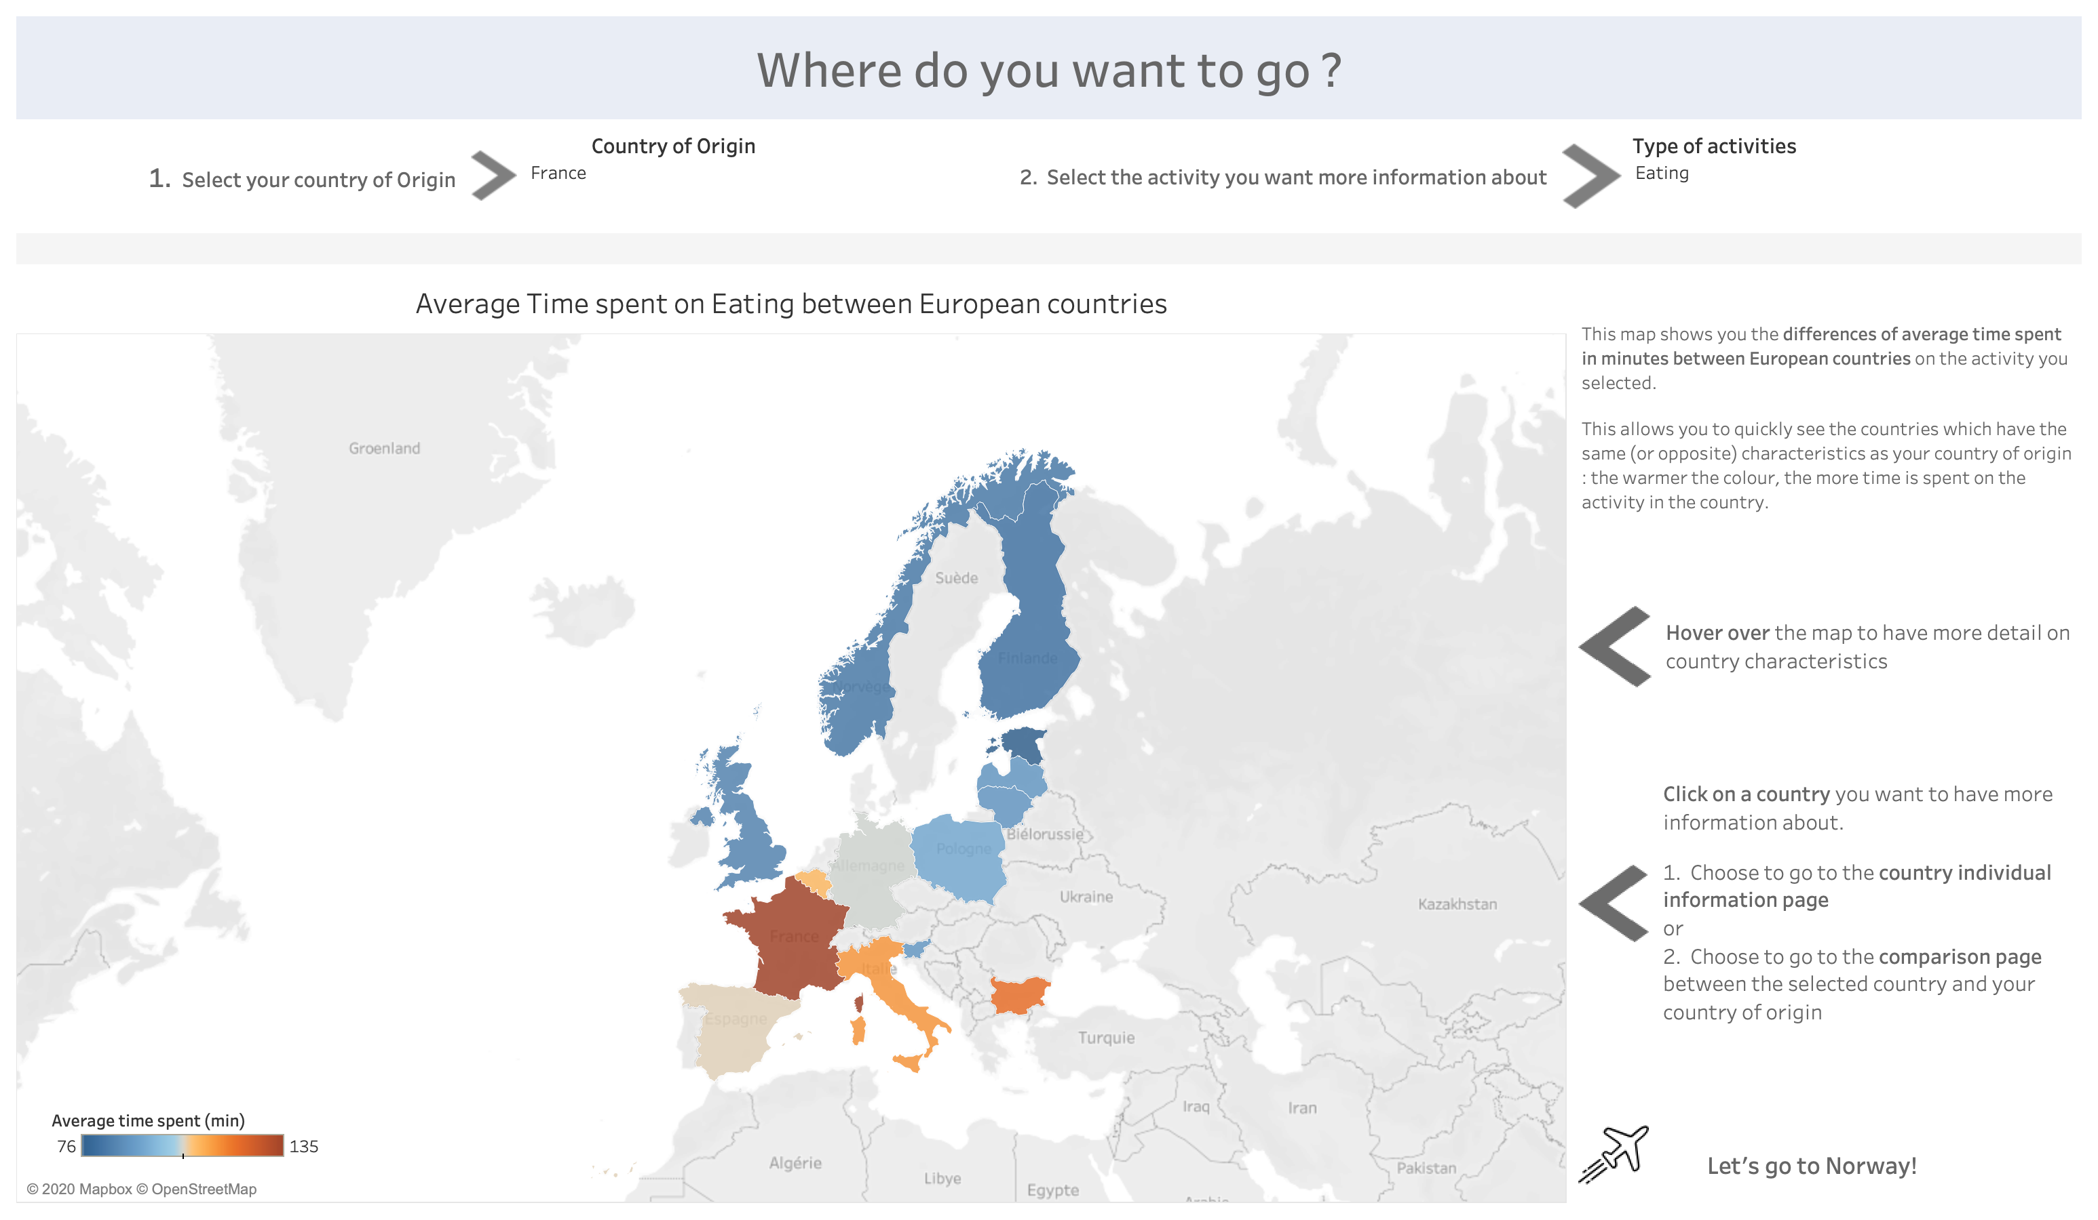

Figure 5. the Welcome page of the application

The representation offered by this page is fairly general: it is a visualization of the daily average time (in minutes) spent on a given activity in the different countries. Our choice for discriminating between countries was that of a color code, and more precisely a standard **heatmap** where blue shades denote lower values, while red shades indicate higher values. This blue-red encoding is widely known and immediately interpretable for any user. On Figure 5 for instance it jumps out at the user that France is the country where most time is spent every day on eating, while Finland is the country where the least time is dedicated to this activity.

The welcome page was designed with one main concern: offer **easy interactions and navigation**. Figure 6 displays the available interactions on the welcome page. The user can first select the country of origin from roll menu (1). This choice will be memorized and applied to all subsequent visited dashboards. From roll menu (2), the user can then choose the activity of interest, which will update the map accordingly.

Finally, it is possible to interact with one country specifically in two ways. By **hovering** over a country, the exact number of minutes dedicated to the activity appears. This complements the heatmap visualization for more accuracy. Then by **clicking** on the country, an interactive menu (3) appears, offering the user the option to “visit” the clicked country. Two navigations links are available. The first one takes the user to the comparison page of our application, while the second link leads to the country information page.

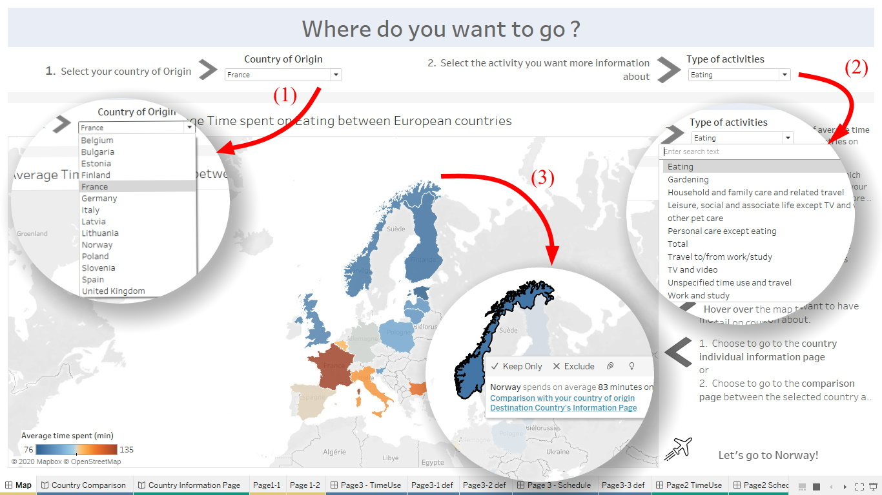

Figure 6. Welcome page: interactions

Here are some sample questions answered from the welcome page:

* How much time do people spend eating in Europe?

Just selecting “eating” as an activity gives a first overview of the discrepancies between the countries, with a scale from 76min to 135min, French spending almost twice more time eating daily than Estonians !

* Are there some other European countries with similar eating habits as Belgium?

Italy and Belgium are about the same color, they spend 110 resp. 115min eating daily. To make sure the habits are the same, we will have to look for more details in the country comparison page.

**3.3 Representations and interactions: country information page**



Suppose our user decided to get specifically information on the country of destination. Clicking on the second link on the welcome page will lead to the page depicted by Figure 7. This page delivers more details on time use in the country of destination. Being again consistent with the natural vision process, the main plot is placed at the top of the page as this is where attention will be first attracted. The graph is a **pie chart** depicting the distribution of time use among the main activities. We choose a pie chart as the circular form provides an accurate perception of the area and hence of the distribution among the different activities. The donut was preferred over the pure pie chart as removing the central part overall yields a better readability of the different portions of the plot and grants more space for the labels.

This first graph shows the distribution of time use among the main activities. A finer representation obtains from two additional plots, on the bottom left and bottom right. These two graphs provide a representation of the ten most important sub-activities in the country of destination. The bottom left graph is a **bubbleplot** providing an overall representation of the 10 most important sub-activities. We retained the bubbleplot for two reasons. First because it is simple, intuitive and quite entertaining. Second, because a bubbleplot displays areas, which are less than linearly perceived by the visual system. This way, slightly less than proportional importance is attributed to the main activities, which facilitates an overall perception by granting sufficient attention to less important activities.

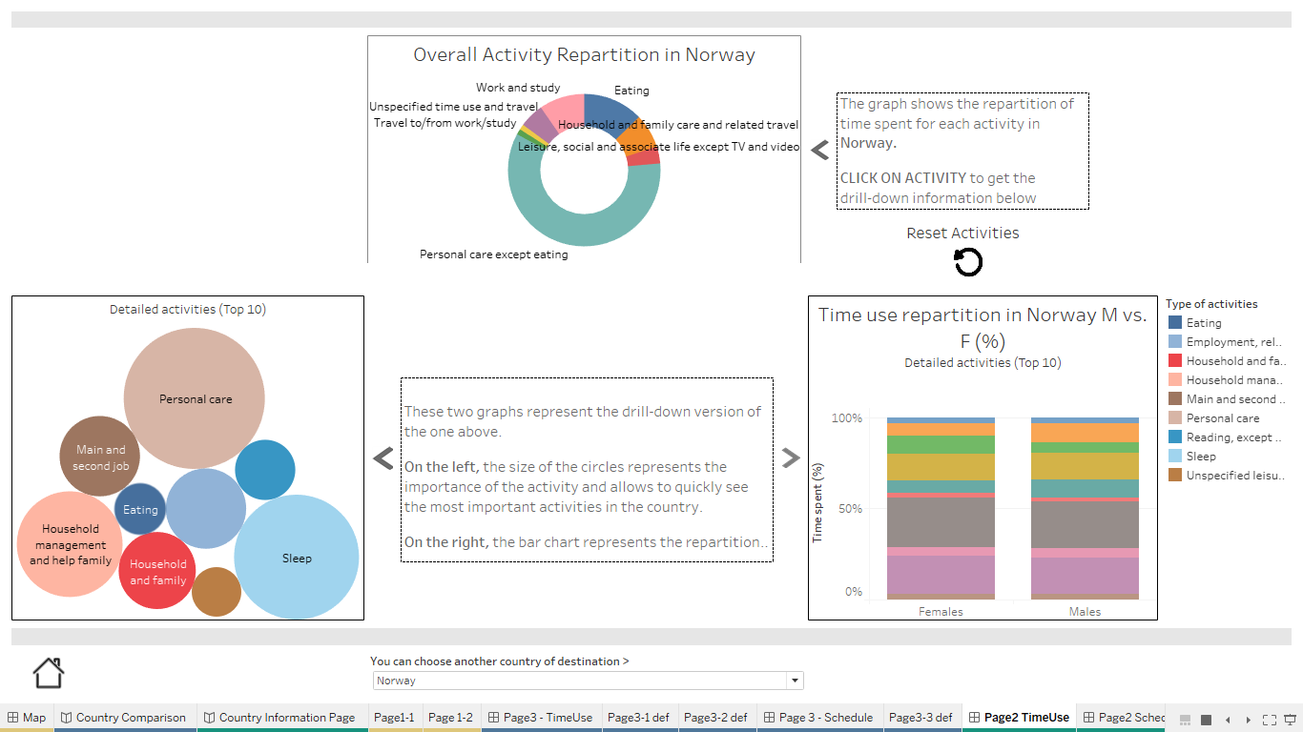

Figure 7. the country information page

The bottom right graph is a **stacked bar chart**. It is the one providing the country information along the male/female axis. Precisely, it compares the percentage of total available time dedicated to the main ten activities for men and women. The stacked bar chart appears especially relevant in this case as it displays lengths, which are quite accurately perceived by the visual system. This way, the comparison across genders remains precise and efficient. Also, as clearly shown on Figure 7, the difference between gender activities are relatively small so that most bars are almost aligned, which further strengthens the visual perception process.

This page also offers a number of interactions, depicted in Figure 8. First, one can hover over a given activity of the pie chart to get its precise minute count. Further **clicking** on this activity isolates the activity in question like (1), and also updates the bubbleplot (2) and the stacked bar chart (3). The update is realized on the sub-activities corresponding to the selected main activity. This lets the user obtain a finer idea of the country identity in terms of one specific activity of interest. This can be of particular interest for instance for women who may wish to discover whether there exists a strong imbalance on certain domestic chores like ironing or doing the laundry.

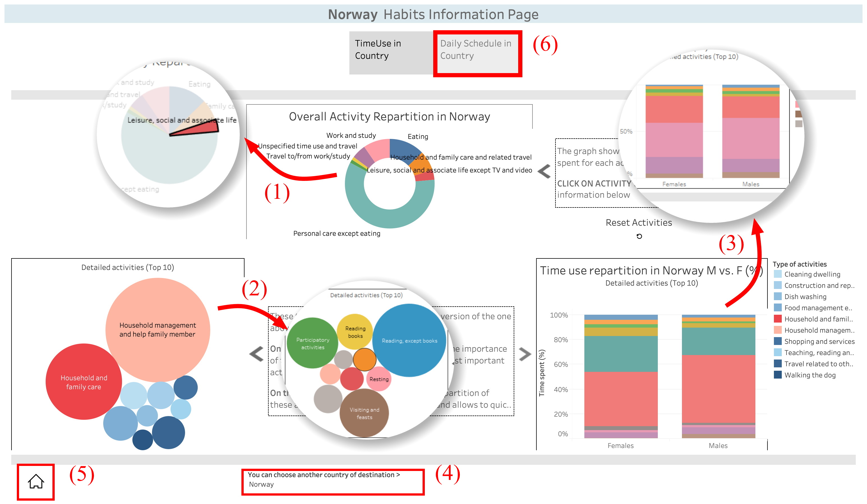

Figure 8. the country information page

Should our traveller be interested in some other country, a roll menu (4) would come handy to select an alternative destination. Once the user has explored the time duration axis, it is time to move and discover other views. One possibility consists in returning to the welcome page by clicking the Home button (5). Perhaps more interesting, the user may navigate to the daily schedule dashboard by clicking the daily schedule button (6) on top of the view.

Questions answered thanks to the country information page include:

* How much time per day does a British citizen spend visiting and feast?

Selecting United Kingdom as a destination, “visting and feast” appears already among the top 10 activities in the bubble chart, with more than 51min daily visiting and feast. Sounds like a good country to interact with people!

* How many minutes does an Italian dedicate daily to ironing?

Selecting Italy as a destination, ironing does not appear in the top10 activities. Let’s select the household filter to get more details : then we see that ironing time is about 10min a day, not that much compared to other activities, but still significant.

* How many hours do you spend at school every day in Bulgaria?

Less than 1hour a day ! As a lazy kid that would be a great country to go to… Or this is rather the limit of this dataset : averaging over the whole population does not make much sense. If interested in activities that are specific to some part of the population, it’s better to go back to the initial database and use another dataset.

One can also find answers to our questions thanks to the gender comparison graph in the country information page:

* Are chores equally distributed between men and women in France?

When France is selected as the destination country, among the stacked bar chart, the women’s “household and family care” is almost twice as high as the men’s one. Selecting this category in the pie chart as a filter for the whole page allows zooming in this category: while men spend more time in “managing” the household work, it is women who do almost all the “cleaning dwelling”. Sad but not that surprising, unfortunately.

* What leisure activities are (not) gender specific in Germany?

When Germany is selected as the destination country, and leisure in the central pie chart : as in many countries, computer games are more popular among men. But surprisingly, unlike many other countries (see Bulgaria for instance), walking and hiking are equally appreciated by both genders in Germany

* Are women heavier readers of books than men in Italy?

When Italy is selected as the destination country, and leisure in the central pie chart : considering “reading, except books” it is almost as popular for both genders, a little more by women. But Italian men spend 1,5 more time “reading books” than Italian women ! Would you have expected this ? Could it be related to what Italian books are about ?

**3.4 Representations and interactions: country time schedule page**



The time schedule dashboard is depicted in Figure 9. The chart shows the percentage of the population busy on the different activities (y axis) over the different time periods of the day (x axis). While producing separate area charts would have been possible, a **stacked area chart** proves preferable as it clearly depicts the relative contribution of each activity over the total population.

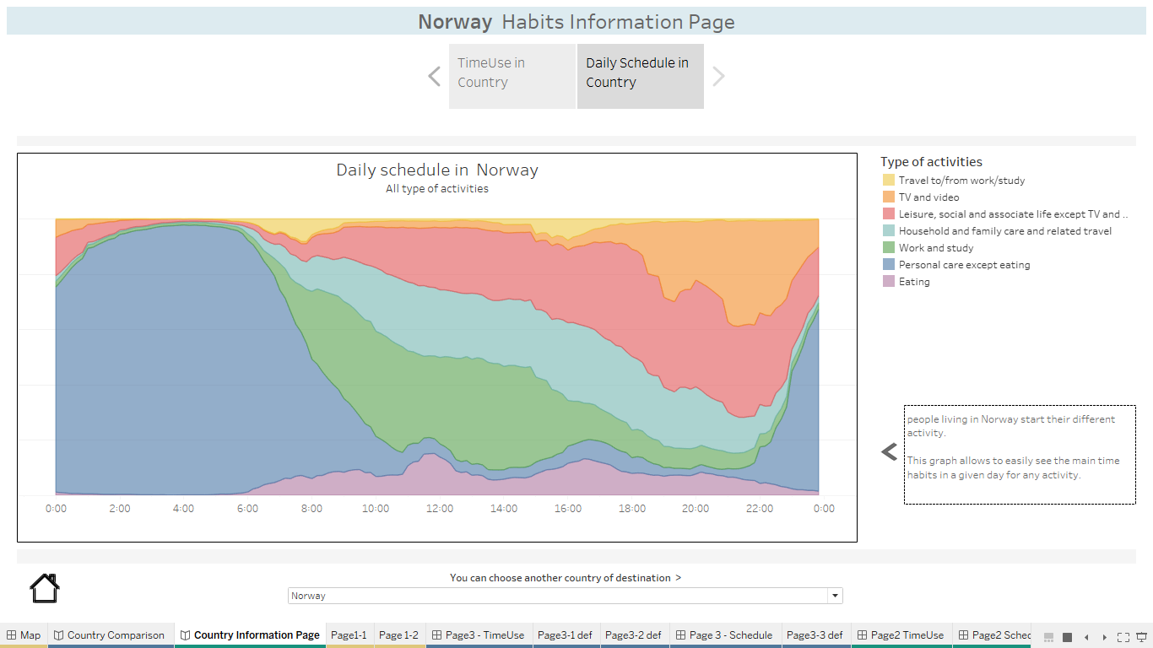

Figure 9. the time schedule information page

The chart offers a number of user interactions, demonstrated in Figure 10. First, hovering over one activity at a given time produces a tooltip that indicates the exact time and percentage of the population busy on the activity. Then, clicking on the activity turns any other activity to white, isolating the selected activity (1) for better visualization. The user still has the option to change the destination country (2), return to the Welcome page (3), or revert to the previous time duration dashboard from top button (4).

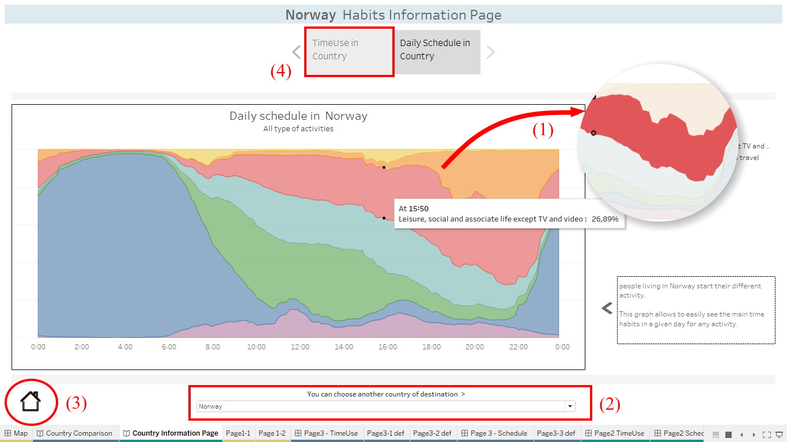

Figure 10. time schedule information page: interactions

Sample answers to our questions thanks to the country time schedule page are:

* At what time do the Finnish typically have breakfast?

Looking at the schedule when selecting Finland as a destination, there is a small peak for eating corresponding to lunch, but the proportion of Finnish people eating is relatively flat all during all morning. It seems that there is no such thing as breakfast at a dedicated time in Finland, rather snacks all morning !

* At what time should I go to the restaurant in Italy?

Looking at the schedule when selecting Italy as a destination, the rush hour for lunch is around 13:20 and the one for dinner around 20:20. Better adjust your habits from Germany, or you may be waiting starving!

**3.5 Representations and interactions: country comparison page**



Take a look back at Figure 6. Should the user click on the first link in (3) rather than on the second one, the navigation would lead to the time comparison dashboard. The latter is shown in Figure 11.

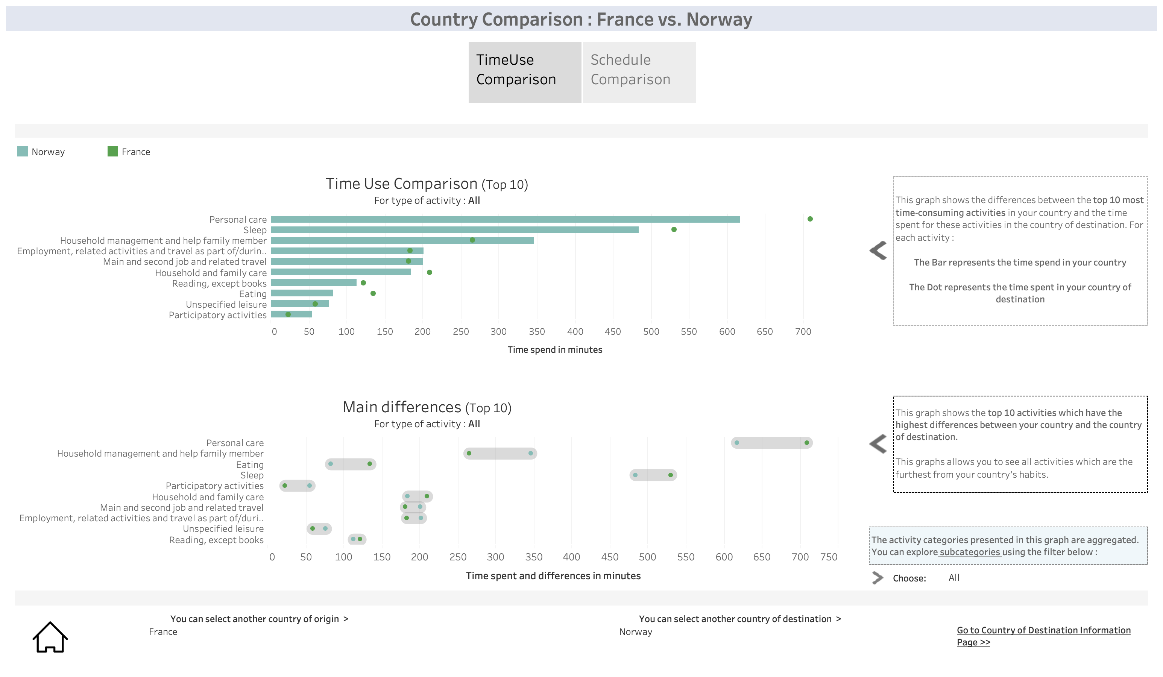

Figure 11. time use information page: interactions

The top graph attracts the user’s view first. It isa **bar chart** comparing the time dedicated to the ten most time-consuming activities in the origin country (the bars) and the destination country (the dots). The choice of a bar chart appears natural here as it produces aligned length which offer maximum perception accuracy. The bars are sorted by decreasing length in order to optimize further the user understanding.

The bottom graph complements the top graph by focusing exclusively on the time difference over the main activities. The **segments** are aligned with the positions of the corresponding activities on the top graph for better interpretability. The activities are nevertheless sorted here by decreasing order of time *difference* in order to let our traveler get a grasp on the main differences between the destination country and the local habits. The top differences really pop out this way.

Quite a few interactions are available on this dashboard, as shown by Figure 12. The most basic interaction consists again in **hovering** over some activity like (1) in order to obtain the exact difference information in minutes. Because activities are aggregated on the base view, it can be interesting to obtain the time difference on sub-activities. Using the roll menu (2), one can select a specific activity, which will in turn update both graphs with the sub-activities like (3). Finally, in the usual logic of fluid navigation, the user can decide both the origin and destination countries with the roll menus (4) and (5). It is also possible to return to the welcome page with the Home button (6), or to move to the schedule comparison panel from top button (7).

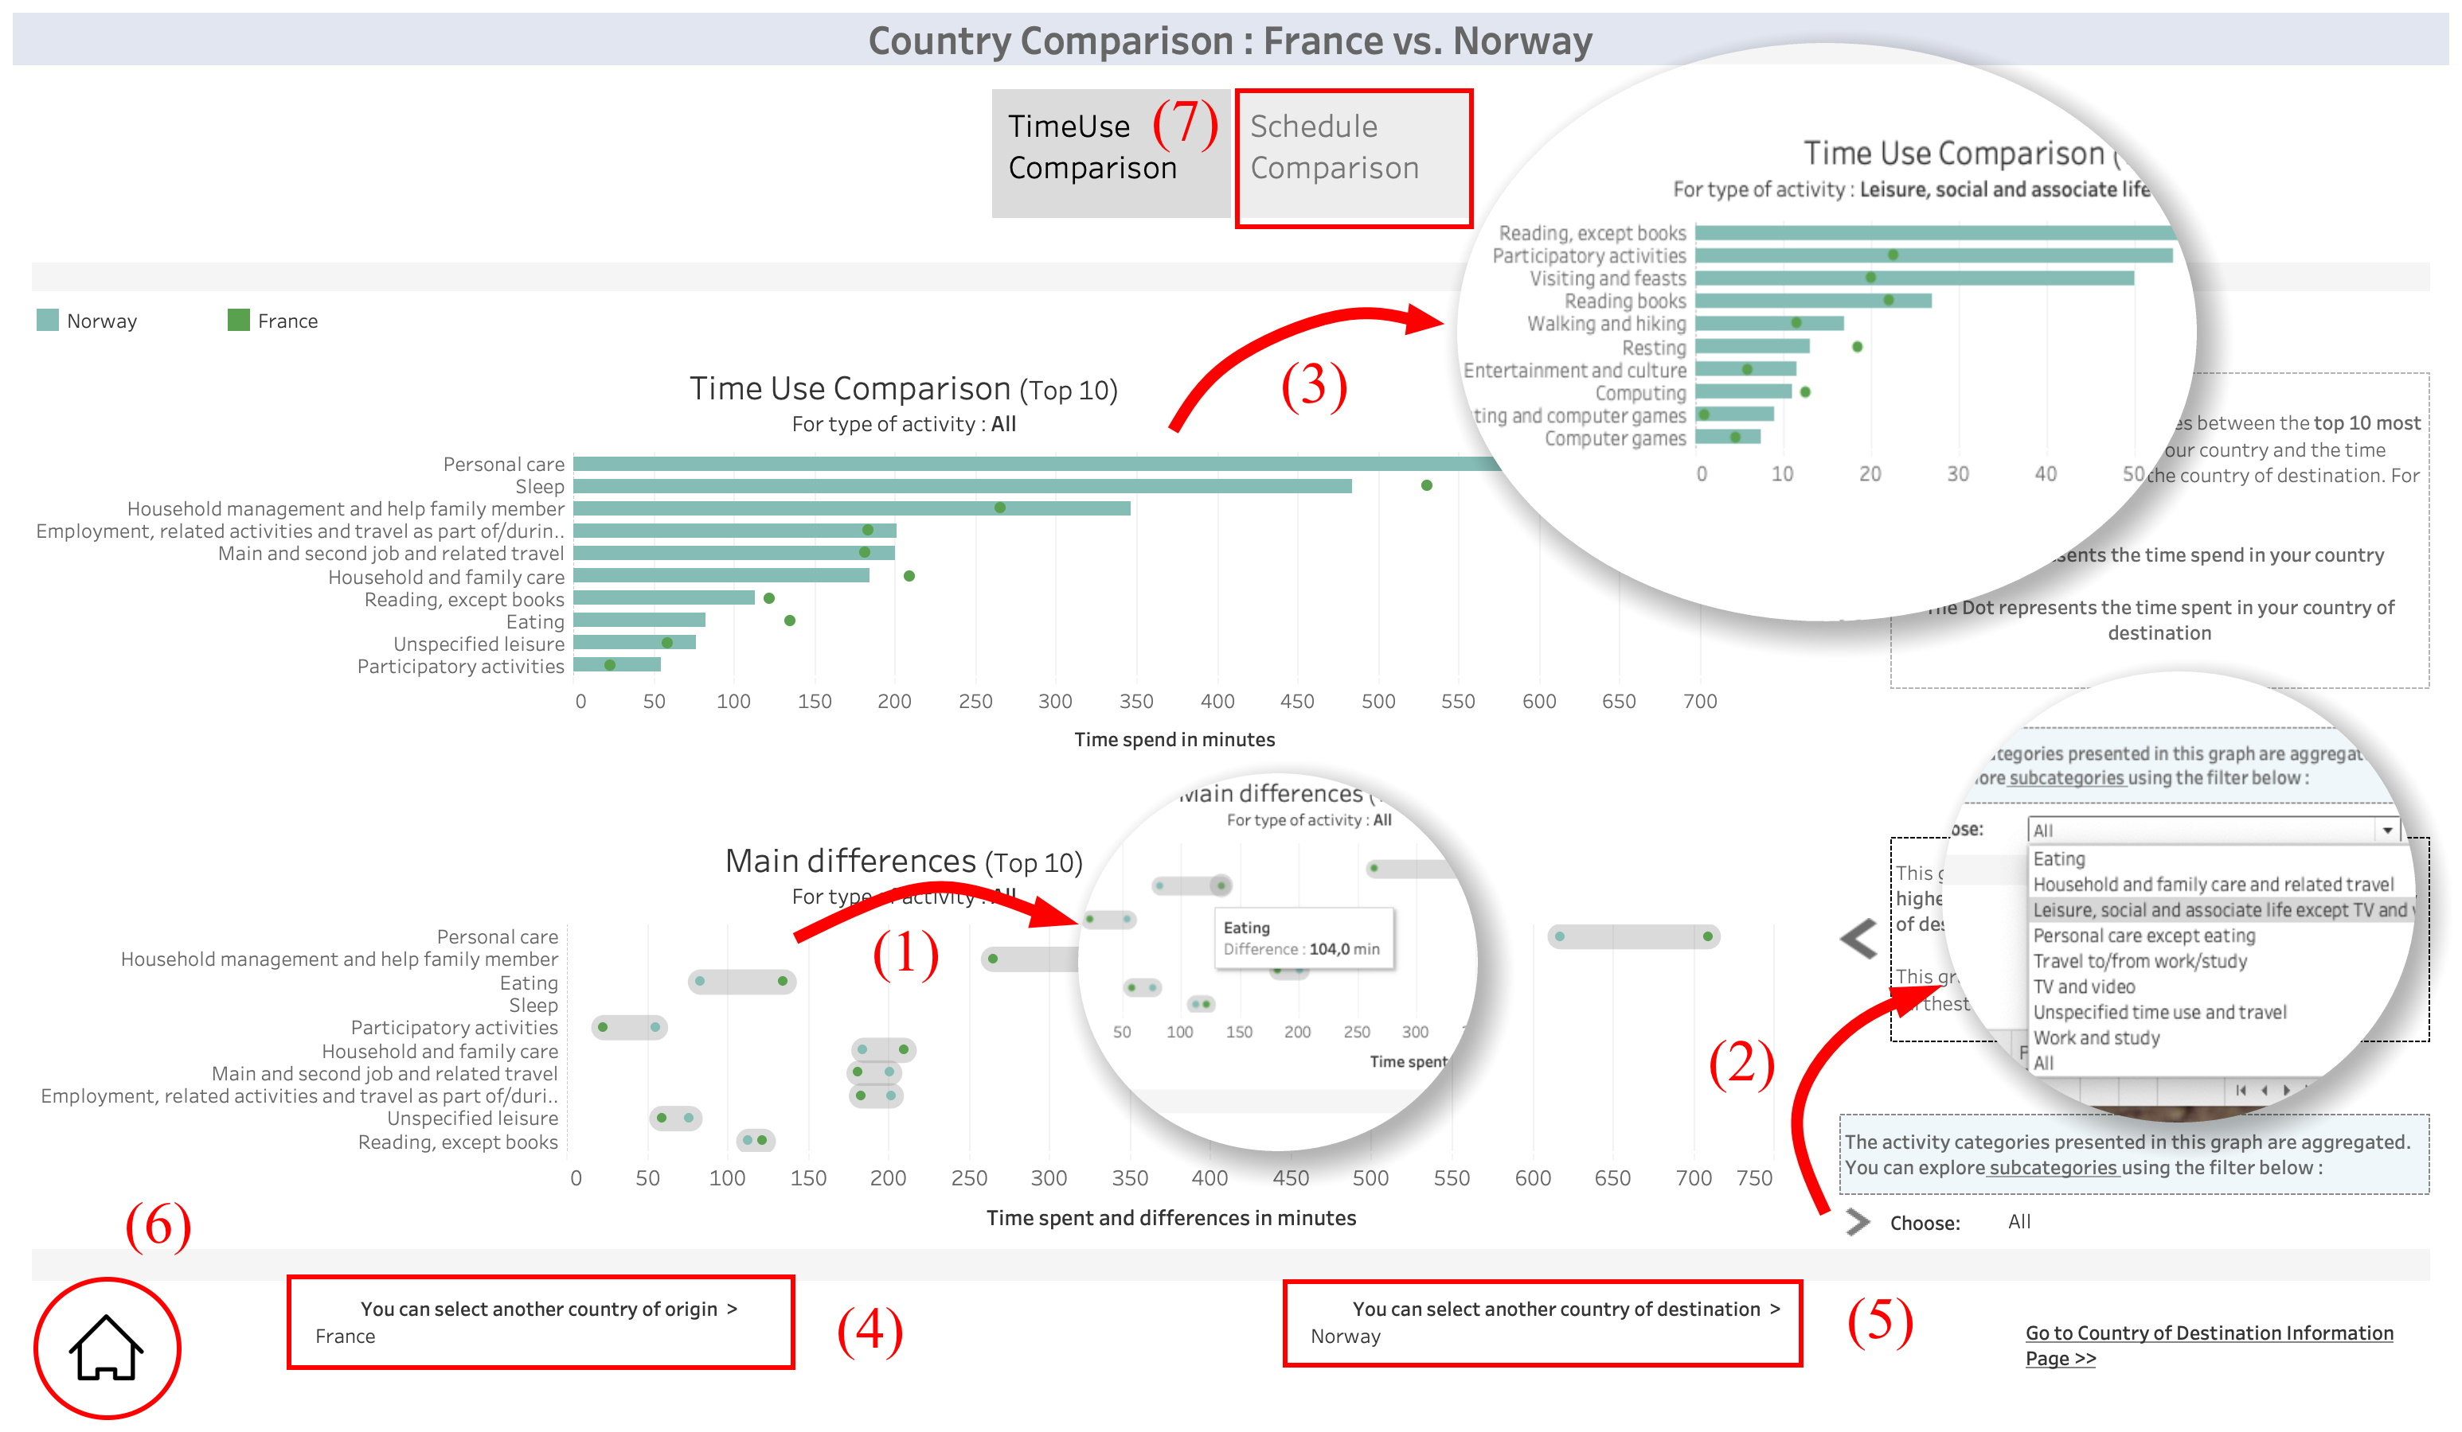

Figure 9. The time schedule information page

Figure 12. the time use information page

Answering a few questions thanks to the time use comparison page:

* What are the main differences in how French and Estonian spend their time?

Looking at the top 4 main differences provides very interesting insights : French people spend much more time at personal care and eating (more than 4h difference), whereas Estonian spend more time at work and travel to/from work (almost 3h difference). Well, which country is a better fit for you may depend on your priorities in life...

**3.6 Representations and interactions: schedule comparison page**



Figure 13 shows the final visualization of our application. It proposes a comparison of time schedules among pairs of origin/destination countries.

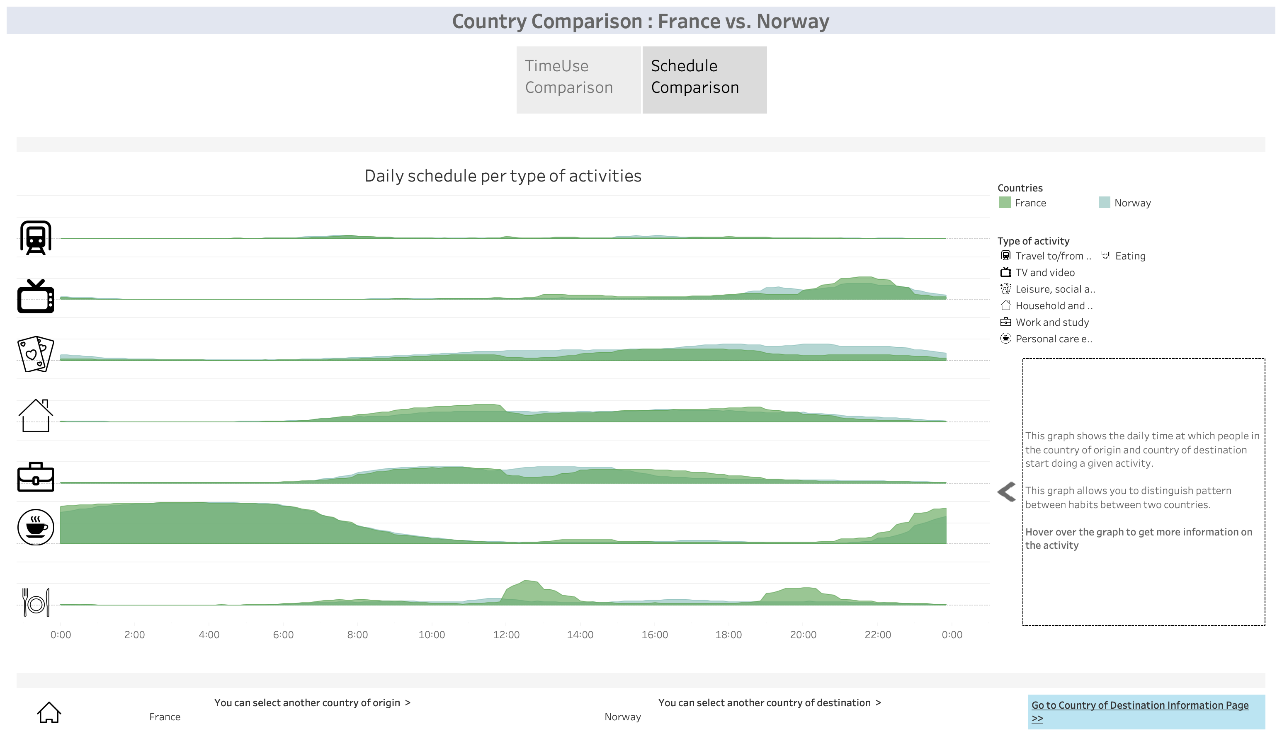

Figure 13. the time schedule comparison page

Figure 13. the time schedule comparison page

Similar to Figure 10, our choice went for **area graphs**, where the x axis represents the time period of the day and the y axis gives the percentage of population participating in the activity. Each graph contains one surface for the country of origin and one surface for the destination country. The **semi-transparency** of the areas makes it possible to adequately visualize the time schedule of each country even on overlapping surfaces. Unlike the visualization for individual countries, it was not possible to combine all the activities on a single graph since the overlapping surfaces would have rendered the plot unreadable. Rather, our visualization comes here as a series of surface plots, one for each activity.

The available interactions are shown in Figure 14. The main interaction consists in **hovering over** an area graph to obtain additional details about the percentage of population running the activity at the selected time. Clicking on a graph like (1) turns the other graphs to grey, including the other country in the comparison, in order to allow for better vision of the country of interest. The user still has the opportunity to change both the departure and destination countries with the roll menus (2) and (3). It is also possible to switch to the destination country information page from button (4) on the bottom right, as well as return to the welcome page with the Home button (5), or move back to the time use comparison page with the top button (6).

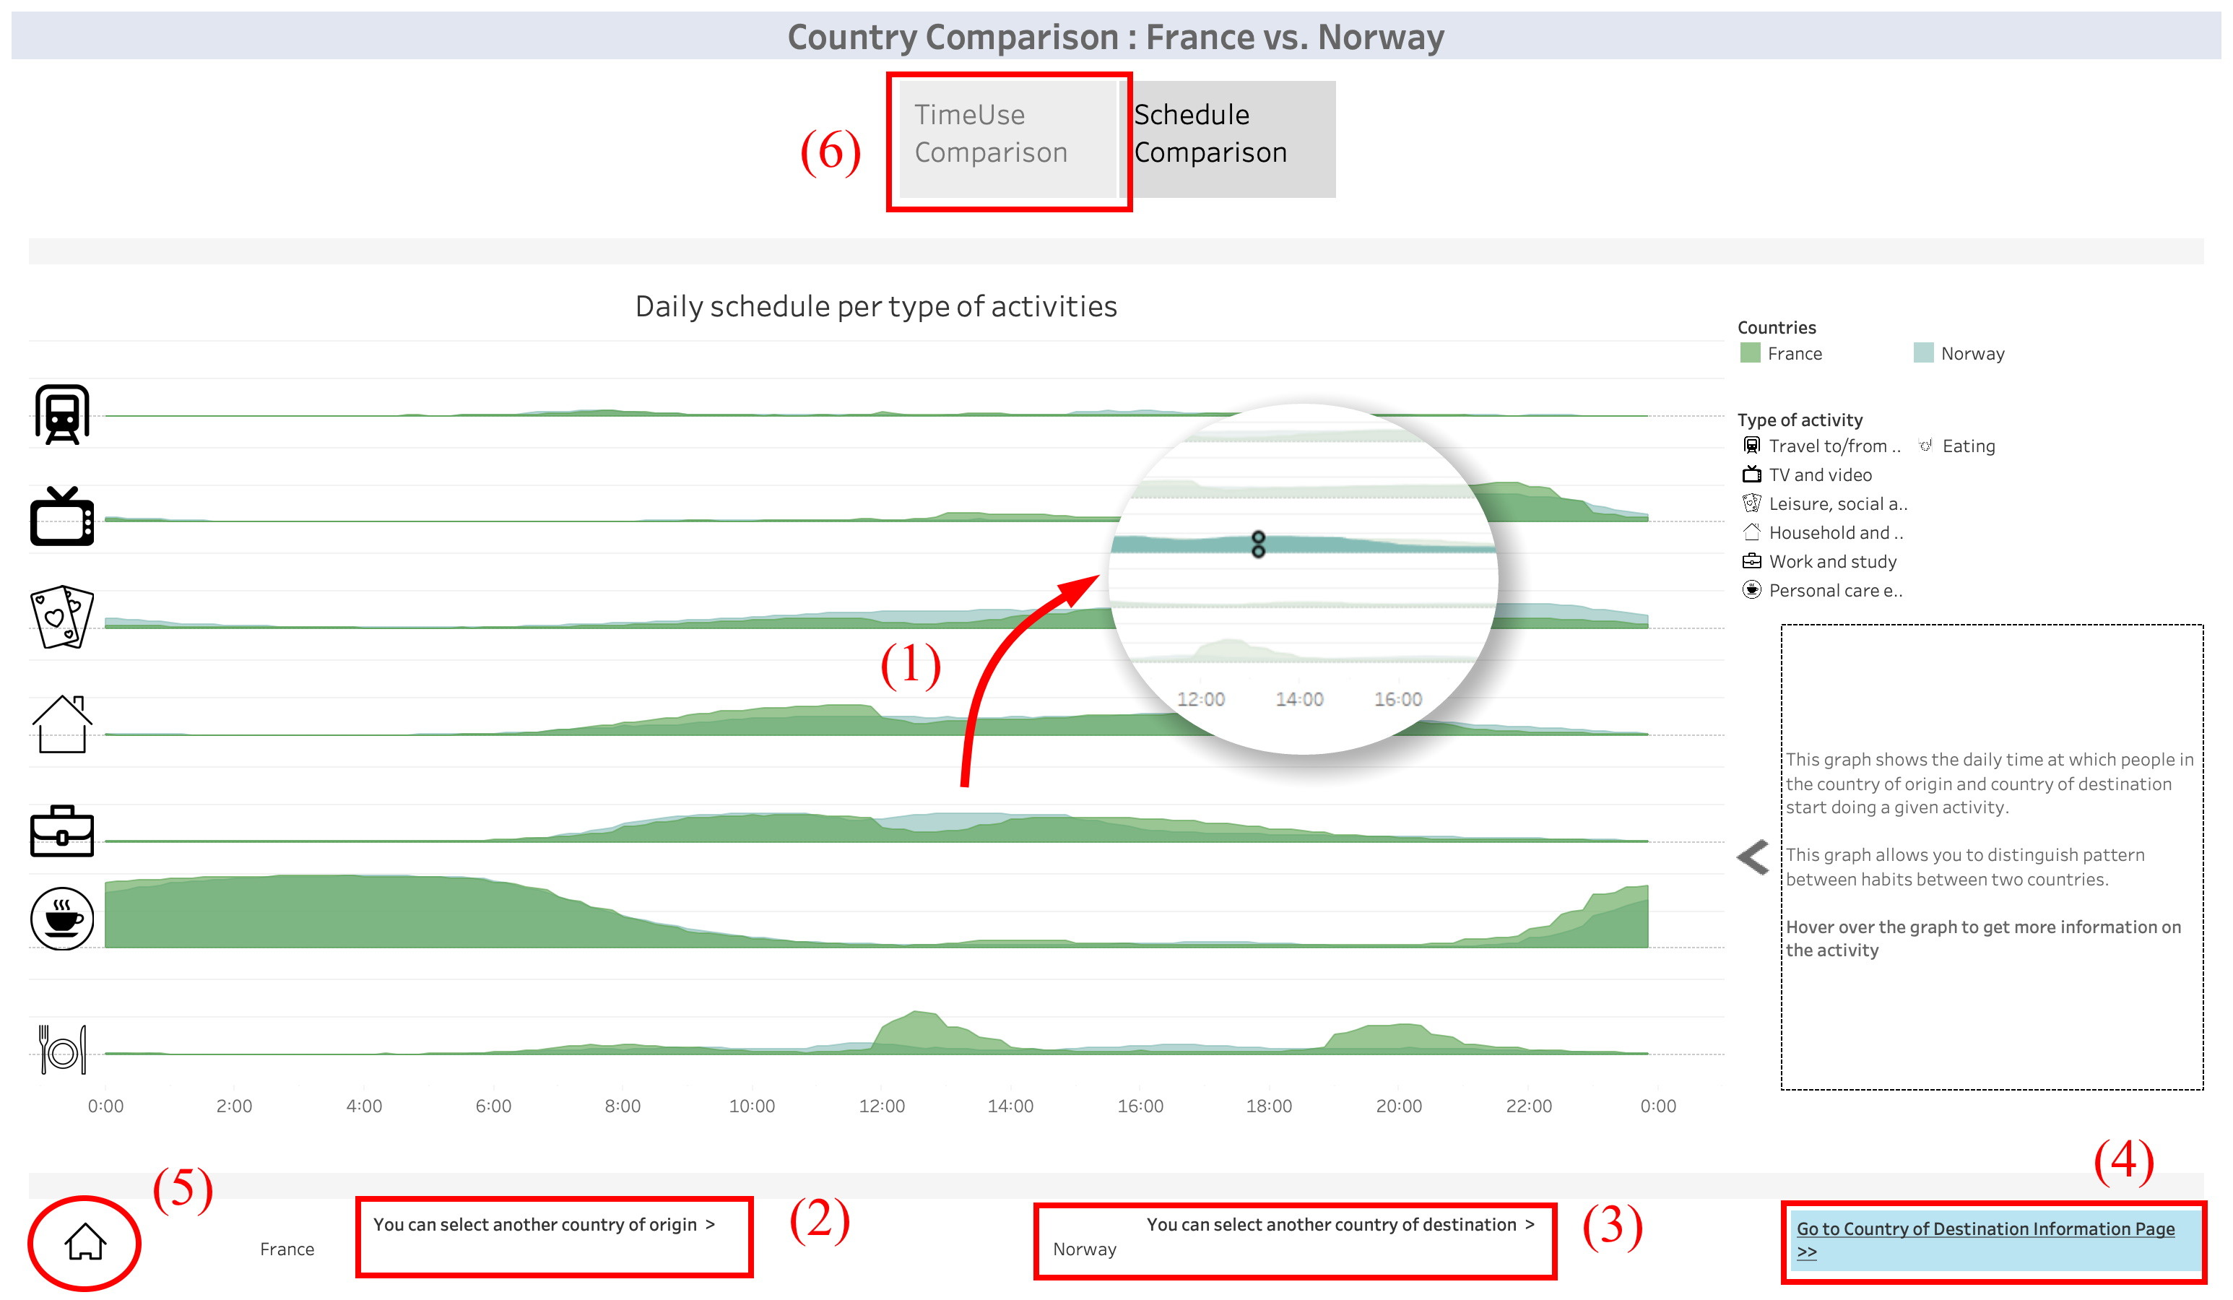

Figure 14. the time schedule comparison page

Answering questions thanks to time schedule comparison:

* As a Finnish, should I prepare to adapt my schedule if I move to Spain ?

Oh yes! Be prepared to have lunch much later than you’re used to, with a real break from work (which means you will also stay later at work). Also add to your schedule spend time eating in the evening at the time you’re used to watching TV, and instead, watch TV late at night !

* Are there some other European countries with similar eating habits as Belgium?

The overview indicated that Belgium and Italy spend about the same amount of time eating daily. Looking at the schedule comparison however, the habits are quite different, they really do not eat at the same time!

**4. Assets and limits**



**4.1 Mains qualities of our design**



Our design does quite a few things well. This includes:

* Provide an **intuitive visualization** of time use in the different European countries, be it in terms of discovery or comparison, time use or time schedule, and for male and female citizens.
* Offer **interactions** permitting a finer representation of time use, be it in terms of countries or individual activities.
* Provide an **easy and guided navigation** across the different dashboards of our application.
* Offer a **clear separation** between the visualization of the different axes developed in our project.
* Offer serious but also **fun and entertaining** visualizations in our dashboards.

**4.2 Limits of our design**



Though quite exciting, our design may face a number of limits. For instance:

* It cannot provide **all the visualizations on a single panel**. There are just too many graphics, and the use of different tabs or “stories” was required. That’s both a weakness and a strength, as Tableau shines at creating such stories. Moving around is nice for travellers, someone interested in sociology may want all at once on the contrary.
* The design struggles at providing a **simultaneous view of all the sub-activities** detailed in the dataset. A preliminary selection of a main activity is usually required. This is not an issue for the kind of questions a traveler wants to answer, whereas a sociologist might have been interested in having a ranking of all countries for each detailed activity.
* The information provided is averaged for the whole population of one country, no matter whether one activity is only relevant for a part of the population (this is inherent to the dataset). This means that questions like “how many hours do you spend at school everyday in Bulgaria?” will not provide you with the intuitive answer (how long do scholars and/or teachers spend at school) but with the time over the whole population.
* It cannot provide a **time schedule representation** of the sub-activities. This constrains the time schedule panels to represent only the main activities. This is however a problem related to the construction of the second dataset we selected, and not to the visualization.